**THE MUTTER MEMORIAL FUN FISH**

**Sunday February 17th, 2013**

**C:\Users\Kevin\AppData\Local\Microsoft\Windows\Temporary Internet Files\Content.IE5\WHBAGD6E\MC900084114[1].wmfC:\Users\Kevin\AppData\Local\Microsoft\Windows\Temporary Internet Files\Content.IE5\WHBAGD6E\MC900084114[1].wmf9am-1pm**

**Keho Lake**

**(ICE PENDING)**

**Mens and Ladies Trophy for BIGGEST FISH**

**Loonie Pools**

**Free Hot Chocolate**

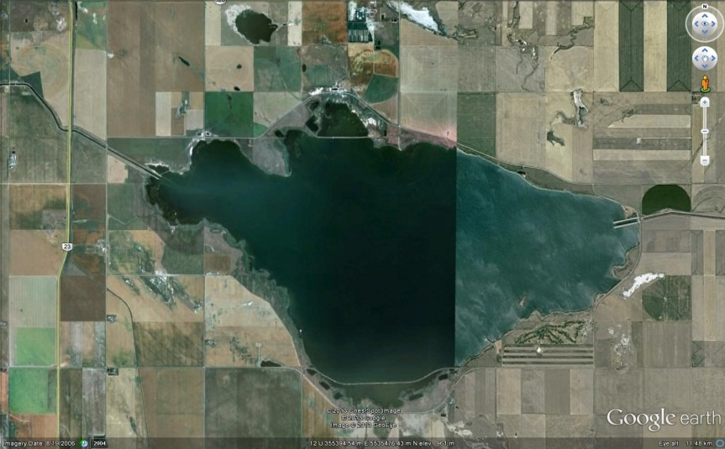**We will be fishing on the north Shore.Look for us as we will be there early!**

**For further information contact Lane Archery 380-2626**